WPL LAB 2
name: Abhinav Singh Bhagtana
section: A
roll no: 29
reg no: 230905225

Q1.Write a web page which contains table with 3 X 3 dimensions (fill some data) and one
image. Style the rows with alternate color. Move the table and image together from right
to left when button is clicked.

<!DOCTYPE html>
<html lang="en">
<head>
<meta charset="UTF-8">
<title>jQuery Toggle Animation</title>
<script src="https://code.jquery.com/jquery-3.6.0.min.js"></script>
<style>
body { font-family: 'Segoe UI', sans-serif; padding: 30px; overflow-x: hidden; }
#move-container {
position: relative;
display: inline-block;
transition: transform 0.3s ease;
}

table { border-collapse: collapse; width: 350px; margin-bottom: 15px; border: 2px solid #333; }
th, td { padding: 12px; border: 1px solid #ccc; text-align: center; }
/* Zebra Striping */
tr:nth-child(even) { background-color: #e8f4fd; }
tr:nth-child(odd) { background-color: #ffffff; }
th { background-color: #34495e; color: white; }

img { width: 350px; height: auto; border: 5px solid #34495e; border-radius: 4px; }

.controls { margin-bottom: 20px; }
button {
padding: 10px 25px;
font-weight: bold;
cursor: pointer;
border-radius: 5px;
border: none;
margin-right: 10px;
}
#animateBtn { background-color: #27ae60; color: white; }
#resetBtn { background-color: #c0392b; color: white; }
</style>
</head>
<body>

<div class="controls">
<button id="animateBtn">Slide Toggle</button>
<button id="resetBtn">Quick Reset</button>
</div>

<div id="move-container">
<table>
<thead>
<tr>
<th>Rank</th>
<th>City</th>
<th>Score</th>
</tr>
</thead>
<tbody>
<tr><td>1</td><td>Tokyo</td><td>98</td></tr>
<tr><td>2</td><td>Paris</td><td>95</td></tr>
<tr><td>3</td><td>London</td><td>92</td></tr>
</tbody>
</table>
<img src="https://picsum.photos/350/150" alt="Random Scenery">
</div>

<script>
$(document).ready(function(){
let moved = false;

$("#animateBtn").click(function(){
if (!moved) {
// Move 300px to the right
$("#move-container").animate({ left: "300px" }, 800, "swing");
moved = true;
} else {
// Move back to original position
$("#move-container").animate({ left: "0px" }, 800, "swing");
moved = false;
}
});

$("#resetBtn").click(function(){
// Instantly snap back
$("#move-container").stop().css("left", "0px");
moved = false;
});
});
</script>

</body>
</html>

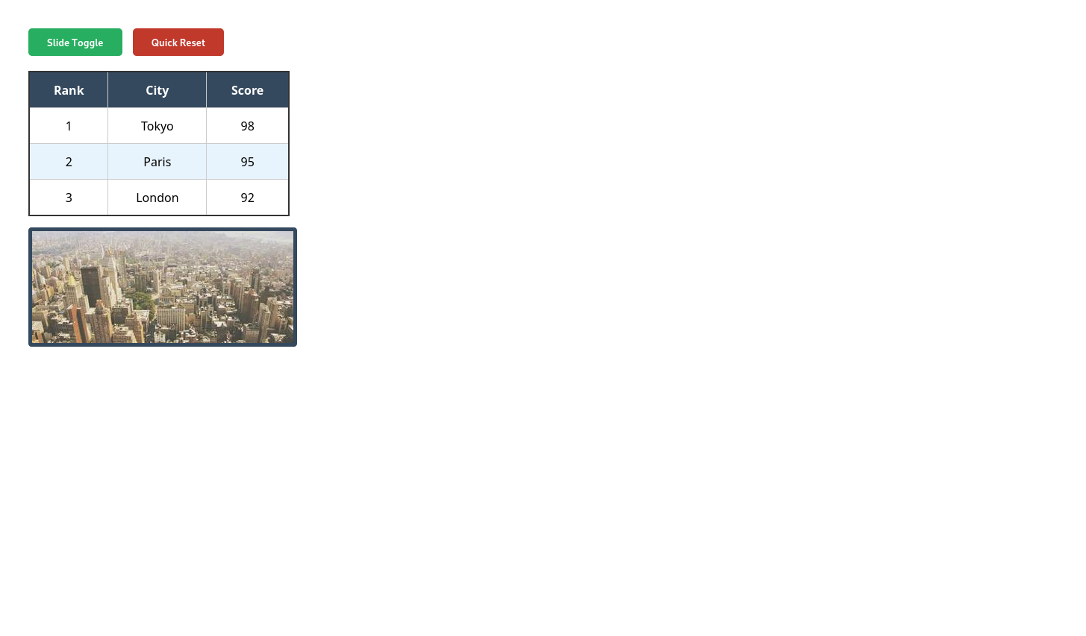
Q2.Design a calculator to perform basic arithmetic operations. Use textboxes and buttons to
design web page.
<!DOCTYPE html>
<html lang="en">
<head>
<meta charset="UTF-8">
<title>Sleek jQuery Calculator</title>
<script src="https://code.jquery.com/jquery-3.6.0.min.js"></script>
<style>
body {
background-color: #2c3e50;
display: flex;
justify-content: center;
align-items: center;
height: 100vh;
margin: 0;
font-family: 'Segoe UI', sans-serif;
}

.calc-body {
width: 320px;
background-color: #1c1c1c;
padding: 25px;
border-radius: 30px;
box-shadow: 0 20px 50px rgba(0,0,0,0.5);
}

/* Screen Styling */
#display {
width: 100%;
height: 80px;
background: transparent;
border: none;
color: white;
font-size: 40px;
text-align: right;
padding: 10px;
box-sizing: border-box;
outline: none;
margin-bottom: 20px;
}

.btn-grid {
display: grid;
grid-template-columns: repeat(4, 1fr);
gap: 12px;
}

button {
height: 60px;
border-radius: 50px; /* Circular buttons */
border: none;
font-size: 20px;
font-weight: 500;
cursor: pointer;
transition: opacity 0.2s, transform 0.1s;
}

button:active { transform: scale(0.95); }

/* Color Coding */
.num { background-color: #333333; color: white; }
.num:hover { background-color: #444; }

.op { background-color: #f39c12; color: white; }
.op:hover { background-color: #ffb132; }

.special { background-color: #a5a5a5; color: black; }
.special:hover { background-color: #d4d4d4; }

.equals { background-color: #f39c12; color: white; }

/* Zero button spans two columns */
.zero { grid-column: span 2; border-radius: 50px; text-align: left; padding-left: 25px; }

</style>
</head>
<body>

<div class="calc-body">
<input type="text" id="display" placeholder="0" readonly>
<div class="btn-grid">
<button class="special" id="clear">AC</button>
<button class="special" id="pos-neg">+/-</button>
<button class="special" id="perc">%</button>
<button class="op" value="/">÷</button>

<button class="num" value="7">7</button>
<button class="num" value="8">8</button>
<button class="num" value="9">9</button>
<button class="op" value="*">×</button>

<button class="num" value="4">4</button>
<button class="num" value="5">5</button>
<button class="num" value="6">6</button>
<button class="op" value="-">−</button>

<button class="num" value="1">1</button>
<button class="num" value="2">2</button>
<button class="num" value="3">3</button>
<button class="op" value="+">+</button>

<button class="num zero" value="0">0</button>
<button class="num" value=".">.</button>
<button class="equals" id="calc">=</button>
</div>
</div>

<script>
$(document).ready(function() {
let display = $('#display');

// Number and Basic Operator Input
$('.num, .op').click(function() {
let currentVal = display.val();
let btnVal = $(this).val();
display.val(currentVal + btnVal);
});

// Clear Screen
$('#clear').click(function() {
display.val('');
});

// Equals Logic
$('#calc').click(function() {
try {
// Using a Function constructor is a slightly safer alternative to eval()
let result = eval(display.val());
display.val(result);
} catch (e) {
display.val('Error');
}
});

// Percentage Logic
$('#perc').click(function() {
let val = parseFloat(display.val());
display.val(val / 100);
});

// Plus/Minus Toggle
$('#pos-neg').click(function() {
let val = display.val();
if(val !== "" && val !== "0") {
if(val.startsWith("-")) {
display.val(val.substring(1));
} else {
display.val("-" + val);
}
}
});
});
</script>

</body>
</html>
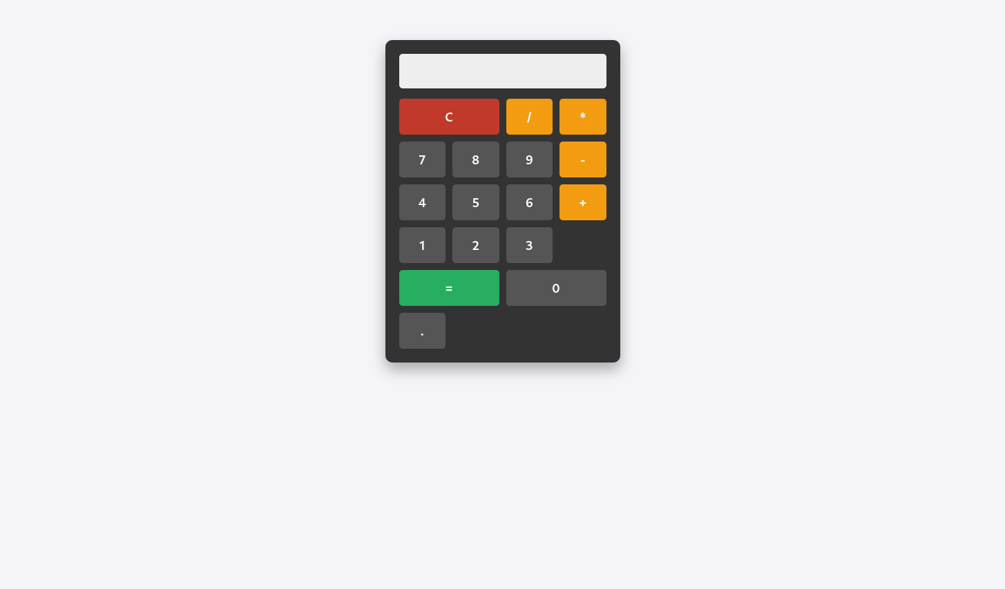
Q3.Create a web page to design a birthday card shown below
<!DOCTYPE html>
<html lang="en">
<head>
<meta charset="UTF-8">
<meta name="viewport" content="width=device-width, initial-scale=1.0">
<title>Birthday Card Designer</title>
<script src="https://code.jquery.com/jquery-3.6.0.min.js"></script>
<style>
body { font-family: Arial, sans-serif; background-color: #fdfde0; padding: 20px; }
.container { display: flex; gap: 40px; max-width: 900px; }
/* Form Styling */
.controls { width: 40%; display: flex; flex-direction: column; gap: 15px; font-size: 14px; }
.controls label { font-weight: bold; margin-bottom: 5px; display: block; }
select, input[type="number"], textarea { width: 100%; padding: 5px; }
.radio-group { display: flex; flex-direction: column; gap: 5px; }
/* Card Styling */
#card {
width: 350px;
height: 450px;
background-color: yellow;
border: 2px solid black;
display: flex;
flex-direction: column;
align-items: center;
justify-content: flex-start;
padding: 20px;
text-align: center;
box-sizing: border-box;
}
#card-text { margin-bottom: 20px; word-wrap: break-word; width: 100%; }
#card-img { width: 200px; display: block; }
button { width: fit-content; padding: 5px 20px; cursor: pointer; }
</style>
</head>
<body>

<div class="container">
<div class="controls">
<div>
<label>Choose a background color:</label>
<select id="bgColor">
<option value="Yellow">Yellow</option>
<option value="Pink">Pink</option>
<option value="LightBlue">Light Blue</option>
<option value="White">White</option>
</select>
</div>

<div>
<label>Choose a font:</label>
<select id="fontFamily">
<option value="Verdana">Verdana</option>
<option value="Arial">Arial</option>
<option value="Courier New">Courier New</option>
<option value="Georgia">Georgia</option>
</select>
</div>

<div>
<label>Specify a numeric font size:</label>
<input type="number" id="fontSize" value="25">
</div>

<div class="radio-group">
<label>Choose a border style:</label>
<label><input type="radio" name="border" value="none"> None</label>
<label><input type="radio" name="border" value="double" checked> Double</label>
<label><input type="radio" name="border" value="solid"> Solid</label>
</div>

<div>
<label><input type="checkbox" id="showPic" checked> Add the Default Picture</label>
</div>

<div>
<label>Enter the greeting text below:</label>
<textarea id="greetingInput" rows="4">Happy Birthday, and many more</textarea>
</div>

<button id="updateBtn">Update</button>
</div>

<div id="card">
<div id="card-text">Happy Birthday, and many more</div>
<img id="card-img" src="https://cdn-icons-png.flaticon.com/512/3132/3132693.png" alt="Cake">
</div>
</div>

<script>
$(document).ready(function() {
$("#updateBtn").click(function() {
// 1. Update Background Color
const bgColor = $("#bgColor").val();
$("#card").css("background-color", bgColor);

// 2. Update Font Family
const font = $("#fontFamily").val();
$("#card-text").css("font-family", font);

// 3. Update Font Size
const size = $("#fontSize").val();
$("#card-text").css("font-size", size + "px");

// 4. Update Border Style
const borderStyle = $("input[name='border']:checked").val();
if(borderStyle === "none") {
$("#card").css("border", "none");
} else if(borderStyle === "double") {
$("#card").css("border", "10px double black");
} else {
$("#card").css("border", "4px solid black");
}

// 5. Update Picture Visibility
if($("#showPic").is(":checked")) {
$("#card-img").show();
} else {
$("#card-img").hide();
}

// 6. Update Text Content
const text = $("#greetingInput").val();
$("#card-text").text(text);
});
});
</script>

</body>
</html>
